MACH4METAL

metalworking machinery
Transito 21
6909 DA BABBERICH Netherlands
Tel. +31 (0)316-247123
Fax: +31 (0)316-247956
info@mach4metal.com
www.mach4metal.com

Bank No : 66.52.13.883
IBAN : NL33 INGB 0665 2138 83
BIC : INGBNL2A

CNC SMD 6.200 x 630 ton 8 axis
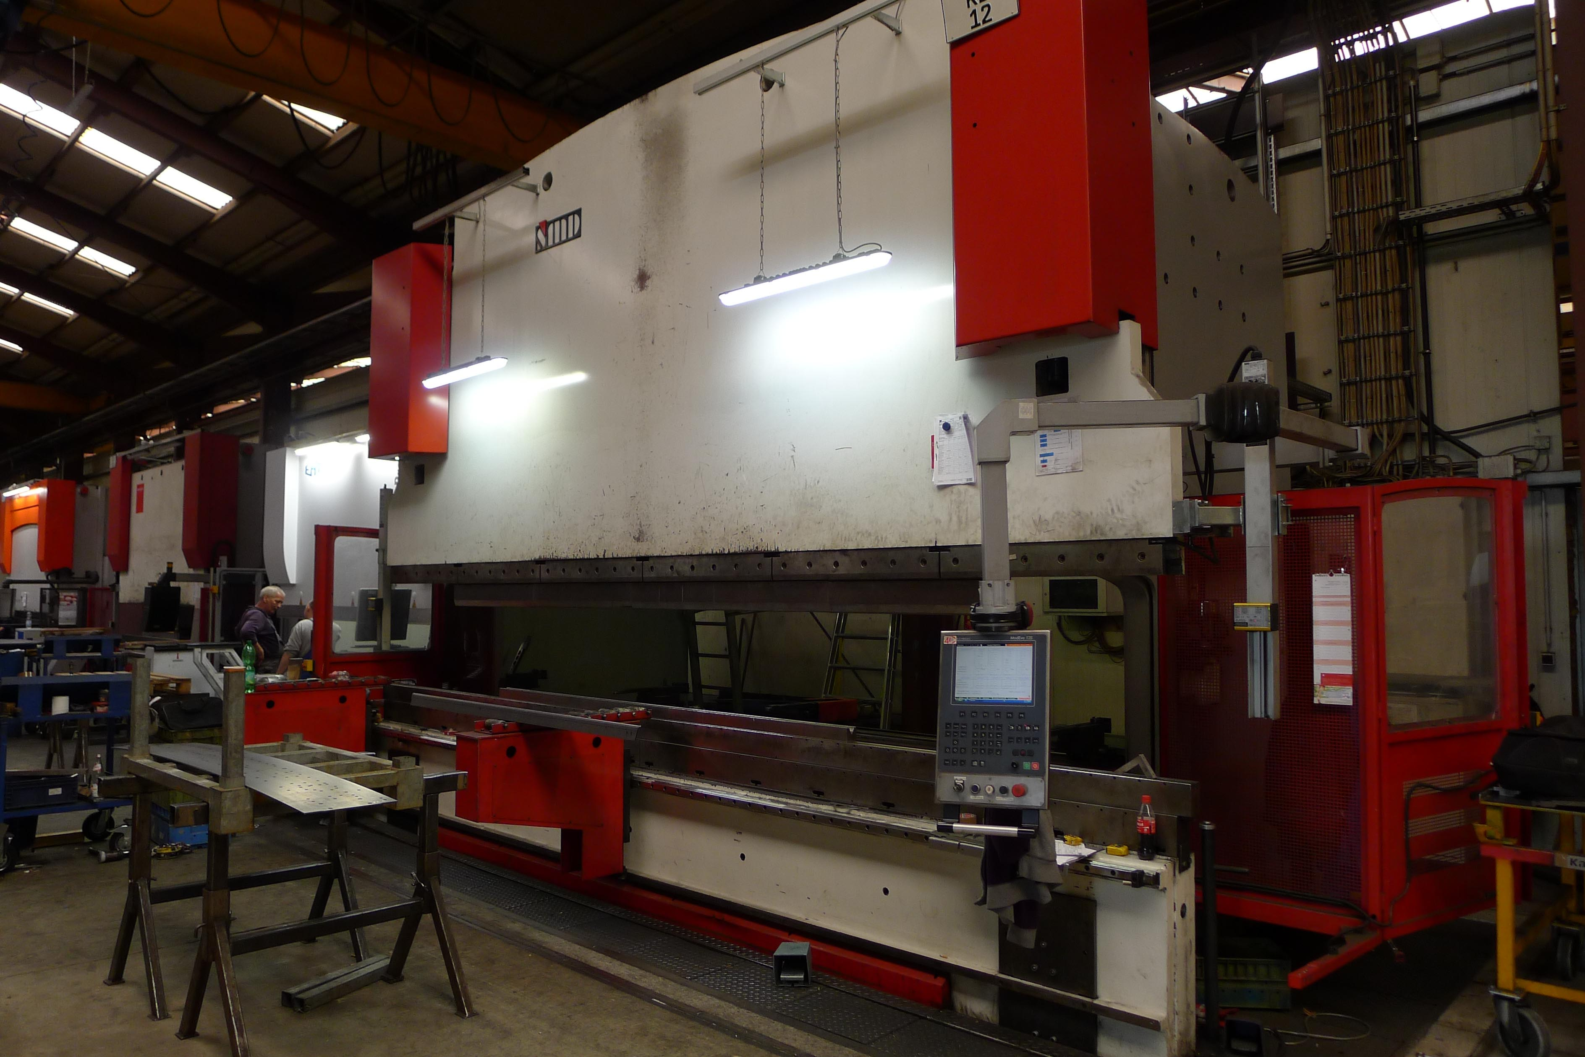
- Make : SMD Europe BV
- Typ : PBH 630/6200
- Mach.No :
- Yop : 2011

- Max. bending length : 6.200 mm
- Between column : 5.100 mm
- Max. Force : 630 ton

- Dis. Beam - Table : 900 mm
- Stroke : 650 mm
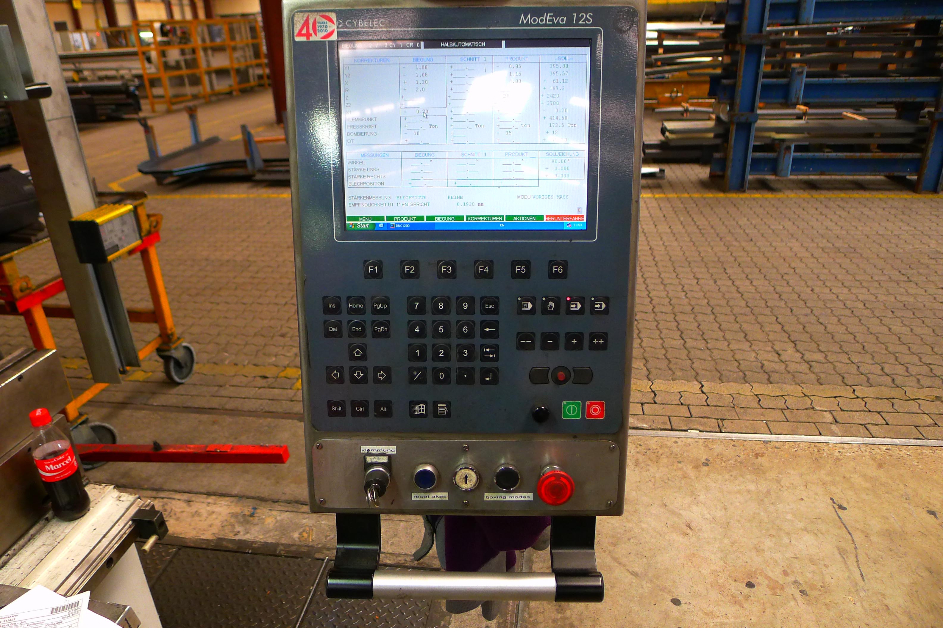
- Throath : 650 mm

- Approch speed : 120 mm/min.
- Working speed : 9 mm/min.
- Return speed : 100 mm/min.

- Cybelec MODEVA 12S
Y1/Y2/X/X1/R/Z1/Z2/V/S Crowning

- Dimensions
- Length : 9.000
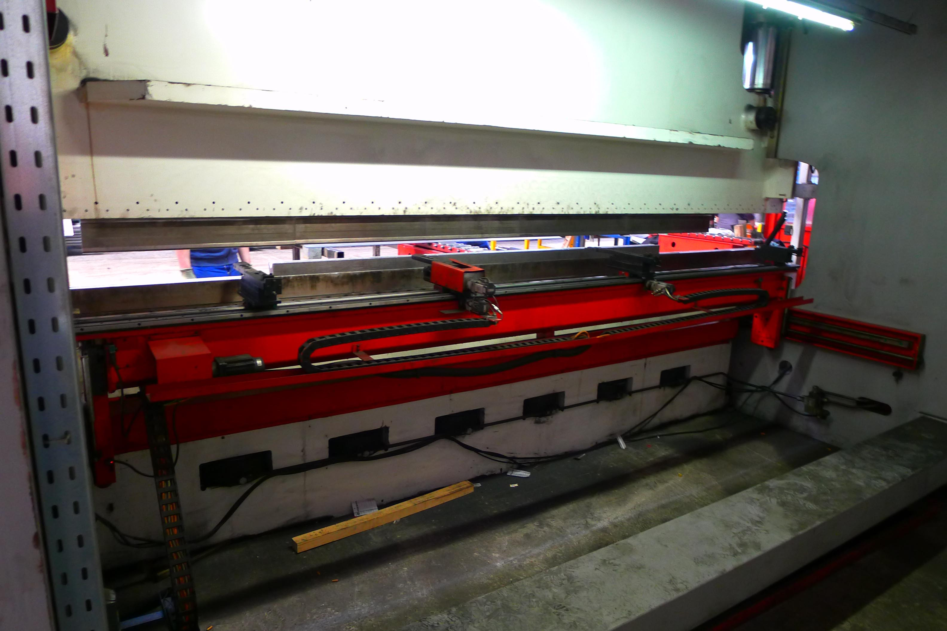
- Width : 2.800
- Height : 5.600
- Weight : 75.000
- Power kW : 45

- Hydraulic upper tool clamp
- Light safety guides
- 4 number off fingers on linear back gauge
- 3 number off arms on front side

Please Note: The above information has been obtained to the best of our ability and belief from, and from the manufacturers where possible. It is given in good faith, but its accuracy can not be guaranteed. Accordingly, it will not form a representation or constitute contractual terms. We advise you to check any vital details!

